Automation of pre-isolation molecular screening for high throughput sampling and sequencing of bacterial microbes from the environment

# ABSTRACT

High throughput of bacterial isolation is crucial in understanding the pattern of antimicrobial resistance in order to combat the wave of antimicrobial resistant bacteria. There are many methods of bacterial culturing such as streaking method and pour-plate method. However, the simplest and most-efficient method for high-throughput bacterial culturing is the spot plating method. This unit outlines to end-to-end protocol for the preparation and isolation of microbes from environmental samples. Here the entire process of environmental sample preparation to the automation and interpretation of results is provided for the high-throughput automation of environmental samples.

# INTRODUCTION

*Acinetobacter baumannii (A. baumannii)* is an opportunistic nosocomial pathogen responsible for a large number of deaths globally due to the rise of antibiotic resistance genes. Existing methods of bacterial isolation, classification and characterisation are either too slow or too expensive, along with generating large amounts of plastic waste. Through utilising the Opentrons-2 open-sourced liquid handler, a relatively cheap, high-throughput and open-sourced method was developed which enabled for a dynamic and easy-to-use protocol which enabled for high throughput isolation of *A. baumannii.*

All the Computer Assisted Design (CAD) Models and Protocol, along with the Guided User Interface (GUI) can be found here:

https://github.com/chinghai98/NTU_High_throughput_bacterial_isolation.git

# TABLE OF CONTENTS

1. ABSTRACT 1

2. INTRODUCTION 1

3. TABLE OF CONTENTS 2

4. PROTOCOLS 2

4.1 Pre-Automation Preparation 3

4.1.1 Preparation of Enrichment Medium 3

4.1.2 Preparation of Environmental Samples 3

4.1.3 Sterilisation of Labware 4

4.1.4 Preparation of Bacterial Growth Medium 5

4.1.5 Pouring of Bacterial Growth Medium 7

4.2 Automation Preparation 8

4.2.1 Preparation of Environmental Samples for Automation 8

4.2.2 Preparation of the Opentrons-2 (OT-2) 8

4.2.3 Layout of Labware in Opentrons-2 9

4.2.4 Software Set-up 13

4.3 Post Automation Processing 14

5. INTERPRETATION OF RESULTS 15

5.1 Layout of “CH_GRID_BOX_PP 300 WELL PLATE 10UL” 15

5.2 Determination of positive samples 16

# PROTOCOLS

## 4.1 Pre-Automation Preparation

### 4.1.1 Preparation of Enrichment Medium

**Baumann Enrichment Medium (pH 6.0) (Baumann, 1968)**

***Reagents and Solutions***

|  |  |
| --- | --- |
| Reagents | Quantity (for 500mL) |
| 5x M9 minimal salt | 5.64g |
| Sodium acetate | 1.0g |
| MgSO4.7H2O | 0.1g |

***Protocol (1x Baumann Enrichment Medium)***

1. Dissolve the above quantities of reagents into 500mL of sterile milli-Q water.
2. Adjust the pH of the solution to 6.0 by adding HCl drop-by-drop, using a pH meter to measure the pH.
3. Autoclave for using the “Liquid” mode for15min at 121oC.

*The entire process will take 1 to 2 hrs.*

1. Allow the Baumann Enrichment Medium to cool down to room temperature.
2. Place the Baumann Enrichment Medium at 4oC for storage.

### 4.1.2 Preparation of Environmental Samples

**Solid Environmental Samples (Soil and Roadside samples)**

The following procedures must be conducted in a Biological Safety Cabinet (BSC) whose surface has been disinfected using 70% ethanol in a BSL-2 certified laboratory.

1. Use a clean 15mL centrifuge tube as a blank for the weighing machine.
2. Weigh 1g of environmental sample and place it into the centrifuge tube.

*Avoid weighing rocks and grass as much as possible*

1. Pipette 3mL 1 x of Phosphate Buffer Saline (PBS).
2. Cap the centrifuge tube and vortex the solution for thorough mixing.
3. Let the centrifuge tube rest to allow for the sediments to settle.
4. Pipette 1mL of the resulting supernatant into a new, sterile 15mL centrifuge tube.
5. Pipette 1mL of Baumann Enrichment Medium (BEM) into the new centrifuge.
6. Cap the new centrifuge tube and seal it with parafilm.
7. Vortex the centrifuge tube for thorough mixing of sample.
8. Incubate at 37oC in a shaking incubator at 200 rpm for 24 hours.

**Liquid Environmental Samples (Water samples)**

1. Pipette 3mL of water using into an empty, sterile 15mL centrifuge tube.
2. Pipette 3mL of Baumann Enrichment Medium (BEM) into the centrifuge tube.
3. Cap the centrifuge tube and seal it with parafilm.
4. Vortex the centrifuge tube for thorough mixing of sample.
5. Incubate at 37oC in a shaking incubator at 200 rpm for 24 hours.

### 4.1.3 Sterilisation of Labware

The following sterilisation procedures must be conducted in either (a) a Biological Safety Cabinet with its surfaces disinfected using 70% ethanol, or (b) Opentrons-2 (OT-2) with its High Efficiency Particulate Air (HEPA) filter switched on.

**Biohazard/Ziploc Bags**

1. Flip the Ziploc bags inside-out as shown in Figure 1.
2. Spray the exposed surfaces of the Ziploc bags thoroughly with 70% ethanol.
3. Leave to the Ziploc bags to dry.
4. Flip the Ziploc bags back outside-in and push-out all the air before sealing it.
5. 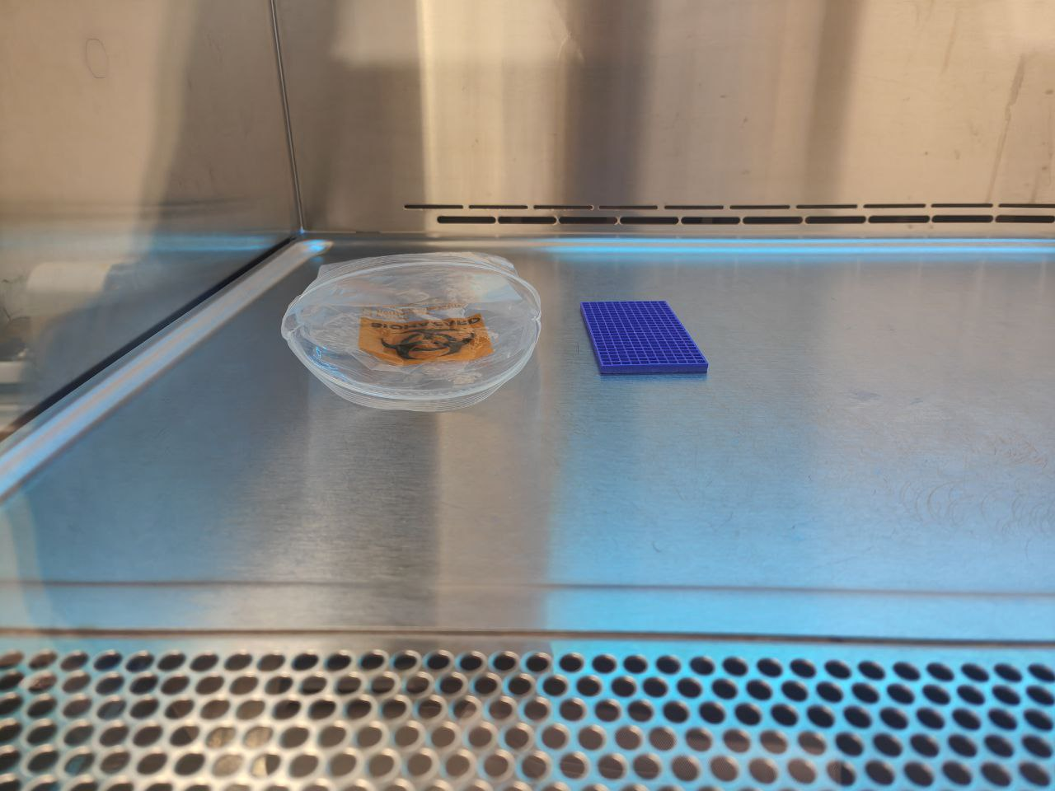Leave under the UVC light for 1 hour to sterilise.

Figure 1. Flipping the Ziploc bag inside out for sterilisation purposes.

**3D_Printed Grids**

1. Prepare tissue papers and lay them out in the Biological Safety Cabinet.
2. Place the 3D_Printed grids onto the tissue paper.
3. Spray the 3D_Printed grids with 70% ethanol.
4. Leave the 3D_Printed grids to dry.
5. Leave under the UVC light for 1 hr to sterilise.

**0.5mL Microtubes**

1. Prepare an empty polypropylene box (not the Shien Polypropylene box)
2. Place the 0.5mL microtubes into the polypropylene box.
3. Autoclave the polypropylene box containing the microtubes using the “Solid” mode at 121oC for 15 mins.

*The entire process will take 1 to 2 hrs*

1. Leave the microtubes either (a) in the Biological Safety Cabinet or (b) in the Opentrons-2 with the HEPA filter turned on to air dry the microtubes.

**Shien Polypropylene Boxes**

1. Remove the cover of the Shien Polypropylene Boxes using a pair of scissors.

*DO NOT throw the cover of the boxes. They are required.*

1. Using the cover, cover the inside of the boxes.

*This step is to minimise contamination of the inside of the boxes post-autoclave.*

1. Autoclave the Shien boxes using the “Solid” mode at 121oC for 15 mins.

*The entire process will take 1 to 2 hrs.*

1. Leave the Shien boxes (a) in the Biological Safety Cabinet or (b) in the Opentrons-2 with the HEPA filter turned on to air dry the boxes.

**NEST 96-well Deep Well Plates**

1. Autoclave the NEST 96-well Deep Well Plates using the “Solid” mode at 121oC for 15 mins.

*The entire process will take 1 to 2 hrs.*

1. Store the deep well plates in a sterile Ziploc bag

*Sterilise using the steps described for the Biohazard/Ziploc bags above.*

### 4.1.4 Preparation of Bacterial Growth Medium

**Modified Leeds Acinetobacter Medium (Jawad, Hawkey, Heritage, & Snelling, 1994)**

***Reagents and Solutions***

|  |  |
| --- | --- |
| **Reagents** | **Quantity (for 500mL)** |
| Bacto Agar | 7.5g |
| Acid Casein Hydrolysate | 7.5g |
| Bacto Peptone | 2.5g |
| NaCl | 2.5g |
| D-Mannitol | 2.5g |
| L-Phenylalanine | 0.5g |
| Ferric Ammonium Citrate | 0.2g |
| Phenol Red | 0.01g |
| D-(-) Fructose | 2.5g |
| Sucrose | 2.5g |
| Vancomycin | 0.005g |
| Cefsulodin | 0.0075g |

***Protocol***

1. Weigh the following reagents on a weighing boat and add them into a 500mL glass bottle:

|  |  |  |
| --- | --- | --- |
| **Reagents** | **Quantity (for 500mL)** | **Remarks** |
| Bacto Agar | 7.5g |  |
| Acid Casein Hydrolysate | 7.5g |  |
| Bacto Peptone | 2.5g |  |
| NaCl | 2.5g |  |
| D-Mannitol | 2.5g |  |
| L-Phenylalanine | 0.5g |  |
| Ferric Ammonium Citrate | 0.2g |  |
| Phenol Red | 0.01g | Dissolve it with 0.02M NaOH first |

1. Add 100mL to 200mL of milli-Q water into the bottle first and close the bottle.
2. Shake the bottle to mix and hydrate the powder.

*Ensure that there is no powder adhering to the walls of the bottle.*

1. Top up the mixture to 400mL of milli-Q water and mix well.

*Do not top it up to 500mL as we will be adding 100mL of Fructose and Sucrose solution after autoclaving.*

1. Open the cap and place it in the microwave oven to heat it.
2. Swirl the mixture after each heating and repeat until the bottle of the agar mixture has a clear turbidity.
3. Loosely cap the bottle to prepare for autoclave.

*Do not close the bottle tightly to allow pressure to be released from the bottle during high temperature heating.*

1. Autoclave the agar mixture using the “Liquid” mode at 121oC for 15 min.

*The entire process will take 1 to 2 hours.*

1. Store the bottle of agar in the oven after autoclave to allow it to cool down to approximately 50oC to 60oC.
2. Weigh the following reagents and add into a 50mL falcon tube each.

|  |  |
| --- | --- |
| **Reagents** | **Quantity** |
| D-(-) Fructose | 2.5g |
| Sucrose | 2.5g |

1. Dissolve each of them with 50mL of milli-Q water.
2. Remove the agar bottles from the oven.
3. Prepare and set up a 10mL sterile syringe and 0.2μm sterile filter. Filter the dissolved D-(-) Fructose and Sucrose solution into the bottle containing 400mL of agar solution and swirl to mix well.

Addition of Antibiotics

1. Use a clean 15mL centrifuge tube as a blank for the weighing machine.

*This tube will be used to weight small volume of antibiotics powder.*

1. Weigh and dissolve 0.005g of Vancomycin powder in 5 to 10mL of milli-Q water directing into the tube using a disposable Pasteur pipette.
2. Using another 15mL microcentrifuge tube, weigh and dissolve 0.0075g of Cefsulodin powder in 5 to 10mL of milli-Q water.
3. Prepare and set up a 10mL sterile syringe and 0.22μm sterile filter. Hydrate the filter with milli-Q water.
4. Filter the antibiotic solution into the bottle of agar mixture and swirl to mix well.

### 4.1.5 Pouring of Bacterial Growth Medium

1. Pour the bacterial growth medium (in this case the *Leeds Acinetobacter Medium*) into the Shien polypropylene box until a height of ~ 2.3 mm.
2. Swirl the medium to eliminate air bubbles.
3. Using a pair of tweezers, gently lower the sterilised 3D_grids into the box.
4. Wait for the growth medium to dry and solidify.
5. Cover the Shien polypropylene box with the cover and seal using parafilm.
6. Seal the boxes containing the medium into the sterilised Ziploc bags.

*Ensure the Ziploc bags are as air-tight as possible.*

1. Store the boxes at a temperature of 4oC.

*Invert the boxes to avoid condensation on the medium.*

## 4.2 Automation Preparation

### 4.2.1 Preparation of Environmental Samples for Automation

1. Pipette 495μL of Phosphate Buffer Saline into the 0.5mL microtube.
2. Pipette 5μL of the incubated environmental sample into the 0.5mL microtube.
3. Cap the microtube and vortex to resulting solution.
4. Repeat for each incubated environmental sample.

### 4.2.2 Preparation of the Opentrons-2 (OT-2)

1. Attach the UVC lamp in the Opentrons-2 (Figure 2).
2. Switch on the Opentrons using the switch at the side of the Opentrons-2.
3. Turn the High Efficiency Particulate Air (HEPA) filter on and set it to “High” setting (Figure 3).
4. Turn the UVC lamp on using the switch (Figure 4).
5. Leave the set-up for ~ 1hr for sterilisation purposes.
6. After 1 hr, switch off the UVC lamp.

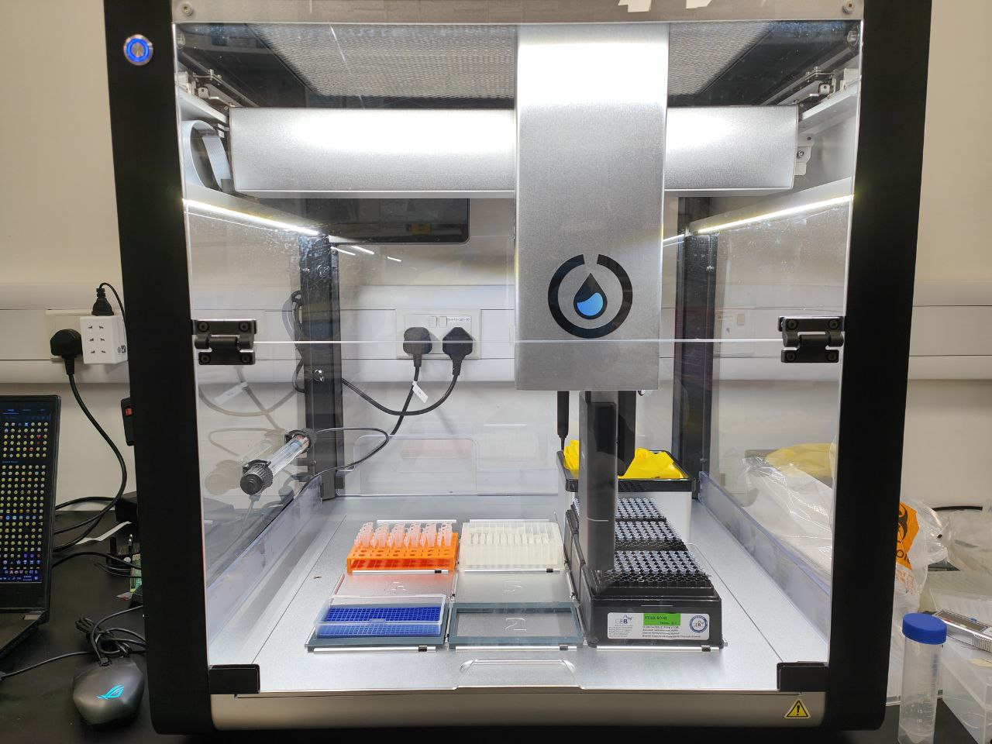

Figure 2. UVC Lamp supported by 2 clamps. Clamps attached to the Opentrons-2 body using 3M-tape (circled in red).

4.2.3 Loading and Placement of Labware

Figure 3. HEPA filter settings (circled in red).

Figure 4. Switch to turn the UVC Lamp on and off.

### 4.2.3 Layout of Labware in Opentrons-2

***Overall layout of labware in Opentrons-2***

Figure 5. Overall layout of labware in Opentrons-2.

If testing between 1 to 24 samples, place the following labware in their respective position as shown in Figure 5.

* Sample Rack 1
* NEST 96 DEEP WELL PLATE 2ML(1)
* OPENTRONS 96 TIP RACK 20UL
* OPENTRONS 96 FILTER TIP RACK 200UL
* OPENTRONS 96 FILTER TIP RACK 200UL(1)
* CH_GRID_BOX_PP 300 WELL PLATE 10UL (1)

If testing between 25 to 48 samples, place the following labware in their respective position as shown in Figure 5.

* Sample Rack 1
* Sample Rack 2
* NEST 96 DEEP WELL PLATE 2ML(1)
* NEST 96 DEEP WELL PLATE 2ML(2)
* OPENTRONS 96 TIP RACK 20UL
* OPENTRONS 96 FILTER TIP RACK 200UL
* OPENTRONS 96 FILTER TIP RACK 200UL(1)
* CH_GRID_BOX_PP 300 WELL PLATE 10UL (1)
* CH_GRID_BOX_PP 300 WELL PLATE 10UL (2)

If testing between 49 to 72 samples, place the following labware in their respective position as shown in Figure 5.

* Sample Rack 1
* Sample Rack 2
* NEST 96 DEEP WELL PLATE 2ML(1)
* NEST 96 DEEP WELL PLATE 2ML(2)
* NEST 96 DEEP WELL PLATE 2ML(3)
* OPENTRONS 96 TIP RACK 20UL
* OPENTRONS 96 FILTER TIP RACK 200UL
* OPENTRONS 96 FILTER TIP RACK 200UL(1)
* CH_GRID_BOX_PP 300 WELL PLATE 10UL (1)
* CH_GRID_BOX_PP 300 WELL PLATE 10UL (2)
* CH_GRID_BOX_PP 300 WELL PLATE 10UL (3)

***NOTE***

For the “CH_GRID_BOX_PP 300 WELEL PLATE 10UL”/ Shien Polypropylene Box to fit into the Opentrons-2 deck, the 3D-printed adaptor has to be utilised.

***Layout of Sample Racks***

Sample Rack 1

Figure 6. Layout of environmental samples in sample rack 1.

Sample Rack 2

Figure 7. Layout of environmental samples in sample rack 2.

***Tip racks***

* For the 200μL tip racks, remove tips from rows ‘G’ and ‘H’.

### 4.2.4 Software Set-up

***Guided User Interface (GUI)***

1. Open the “User_Interface” executable file (.exe) (Figure 8).
2. Select the “Protocol_automate_72_samples” from the directory it is saved in and select the “Open” button (Figure 9).
3. Enter the number of environmental samples in the “Number of environmental samples (1 to 72)” and click the “Save” button.



Figure 8. User Interface executable (.exe) file

Figure 9. Location of "Protocol_automate_72_samples" file.

Figure 10. Enter number of environmental samples and save the input.

***Uploading and Execution of Protocol***

1. Open the Opentrons-2 application.
2. Under “Protocol” tab, select “Import” and upload the modified “Protocol_automate_72_samples.py” file from the directory it is saved in.
3. Run the protocol.

***NOTE***

* If it is the first time using the Opentrons, ensure that a P20_single_channel_gen2 is attached to the left side and P300_multi_channel_gen2 is attached to the right side.
* Ensure that the pipette heads are properly calibrated prior to running the protocol.

## 4.3 Post Automation Processing

1. Allow for the set-up to rest to dry for 15 mins.
2. Place the Shien Polypropylene boxes cover over the Shien Polypropylene Boxes (“CH_GRID_BOX_PP 300 WELL PLATE 10UL” in the layout).
3. Seal the boxes using parafilm.
4. Invert the boxes containing the samples and incubate them at 44oC for up to 24 hrs.

# INTERPRETATION OF RESULTS

## 5.1 Layout of “CH_GRID_BOX_PP 300 WELL PLATE 10UL”

***CH_GRID_BOX_PP 300 WELL PLATE 10UL (1)***

Figure 11. Sample layout for the first polypropylene box w/ grids.

***CH_GRID_BOX_PP 300 WELL PLATE 10UL (2)***

Figure 12. Sample layout for the first polypropylene box w/ grids.

***CH_GRID_BOX_PP 300 WELL PLATE 10UL (3)***

Figure 13. Sample layout for the first polypropylene box w/ grids.

## 5.2 Determination of positive samples

For *Acinetobacter baumannii,* if a particular grid changes colour from yellow-gold to pink-red, then *Acinetobacter baumannii* is likely to be present.

For actual determination if sample is *Acinetobacter baumannii*, PCR needs to be carried out.